**RETAIL INDUSTRY**

**Definition of retail Industry**

Retailing is the combination of activities involved in selling or renting consumer goods and services directly to ultimate customers for their personal or house hold use. In addition to selling retailing include such diverse activities as buying, advertising, data processing, man power management and maintenance of the inventory.

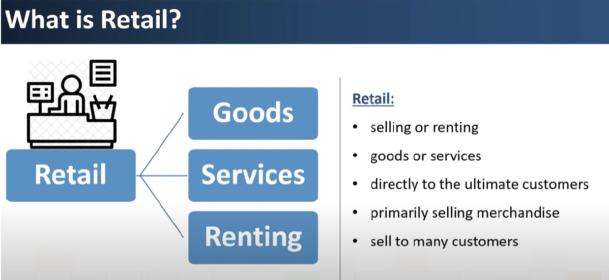

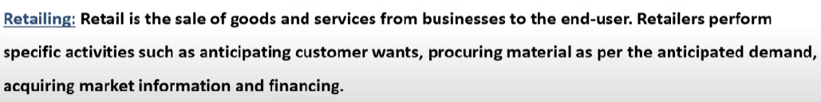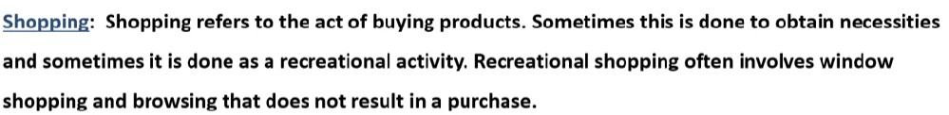**Shopping vs Retailing**

**Retail Examples**

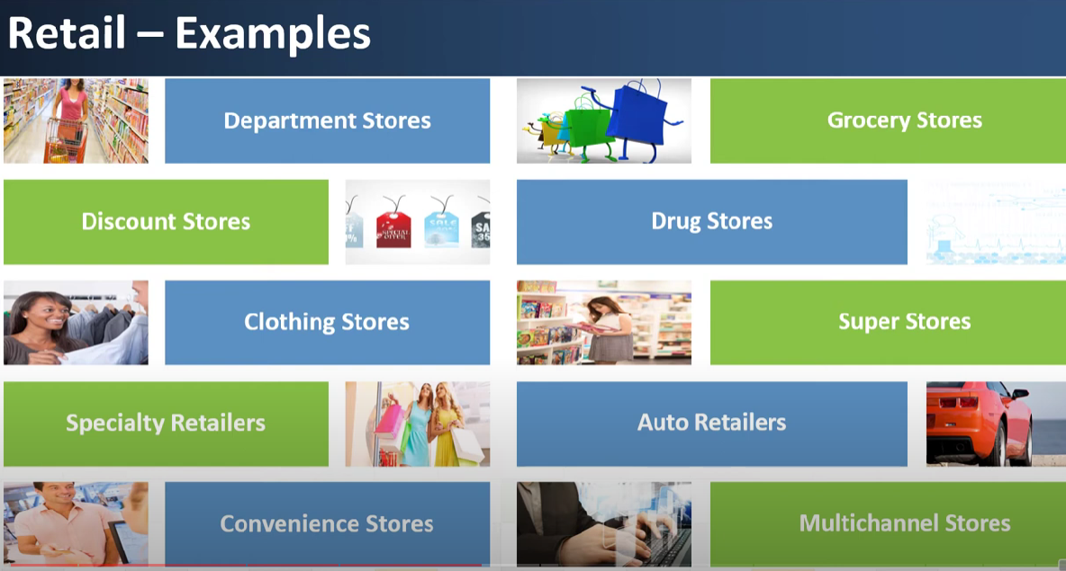

**Retail Activities**

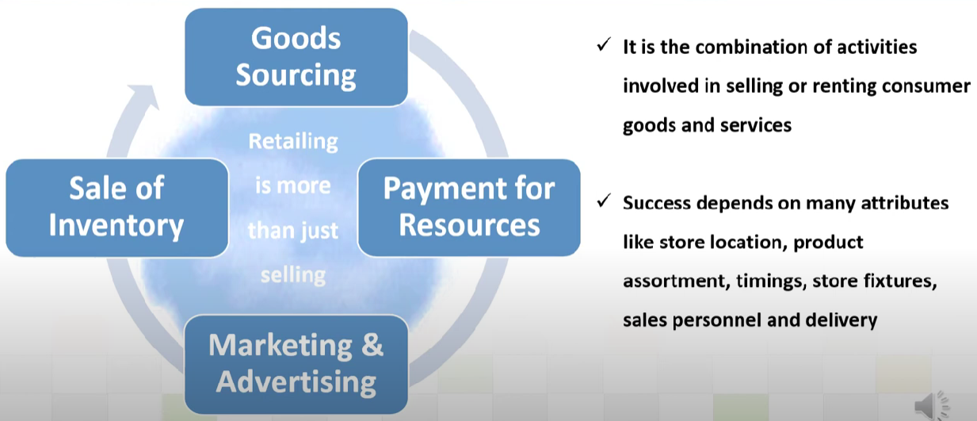

**Impact of Retail on country’s Economy**

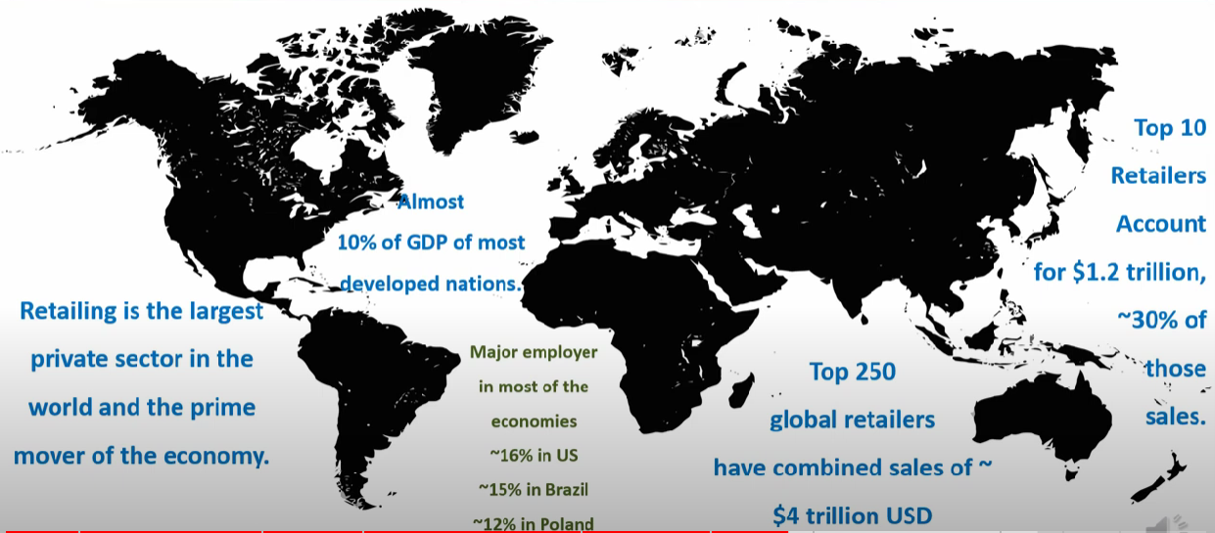

**Note : To find more on the statistics of Retail click on to below link**

[**https://www.statista.com/topics/5922/retail-market-worldwide/#topicOverview**](https://www.statista.com/topics/5922/retail-market-worldwide/#topicOverview)

**Data on Retail Industry in USA**

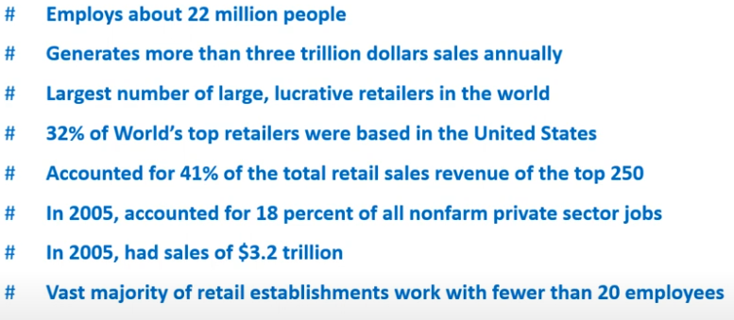

**Data on Retail Industry in Japan**

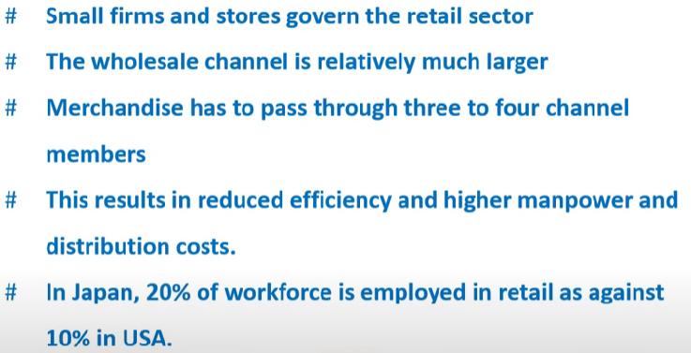

**Data on Retail Industry in India**

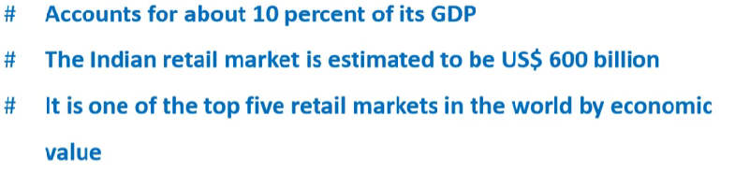

**Importance of Retail Industry**

**Importance of Retail Industry**

1. **Customer Convenience**

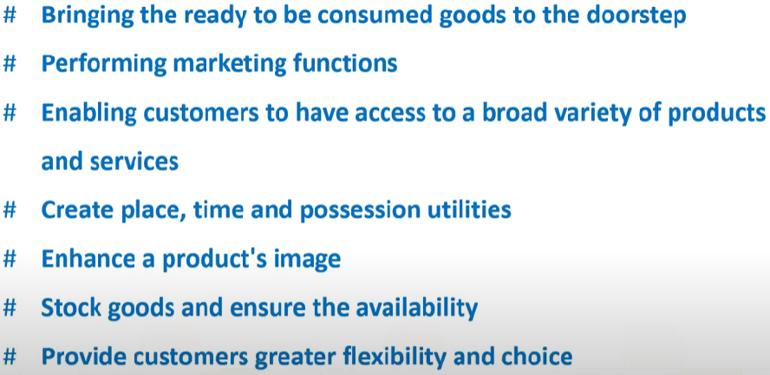

1. **Accessibility**

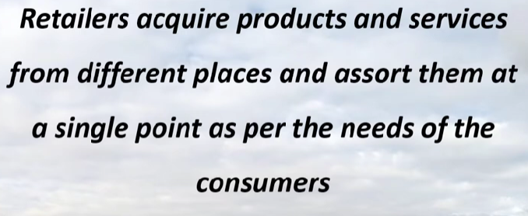

1. **Convenience of Size**

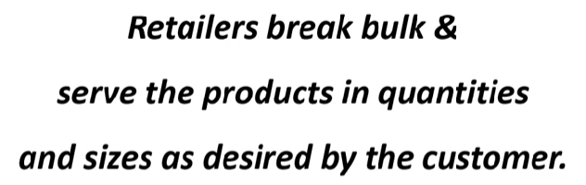

1. **Supply Chain**

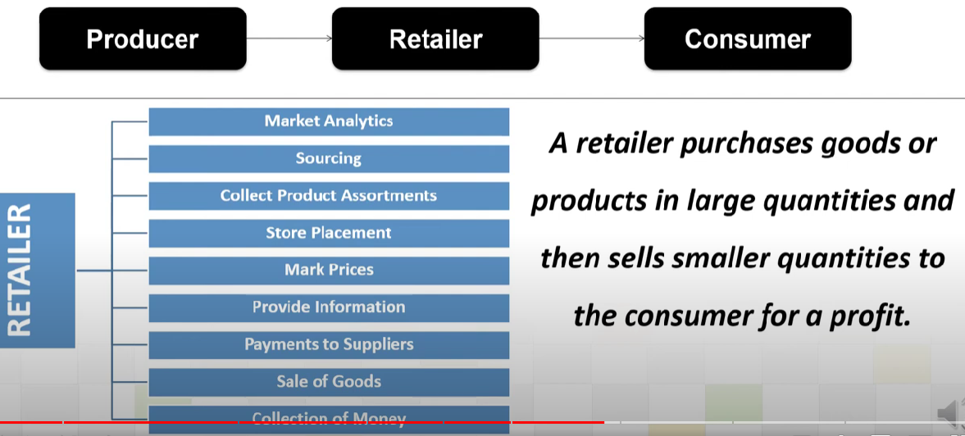

1. 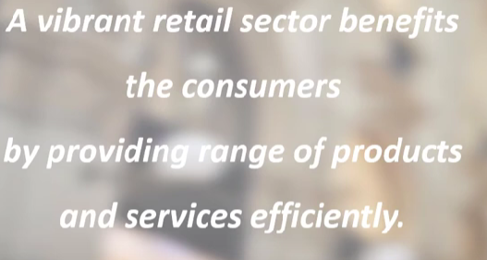**Associated Services**
2. **Value Chain (Mobilizes the Savings and Investment of People)**

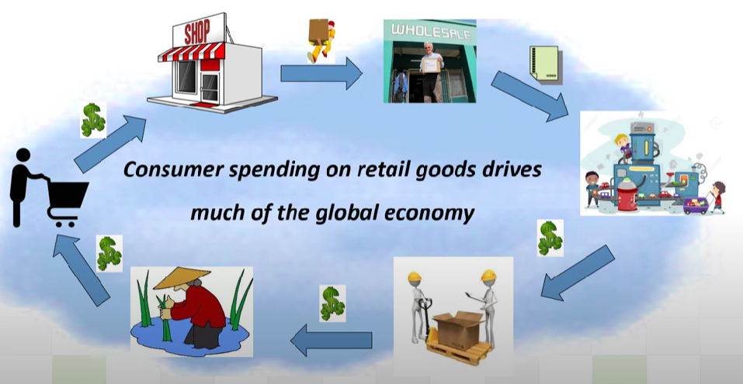

1. **Employment**

**Shopkeeper, Cashier, Marketing, Accountant, Store Manager, Retail Trainee,**

**Manager, Customer Service, Security Officer…. And many more.**

**Business Model**

**Formats**

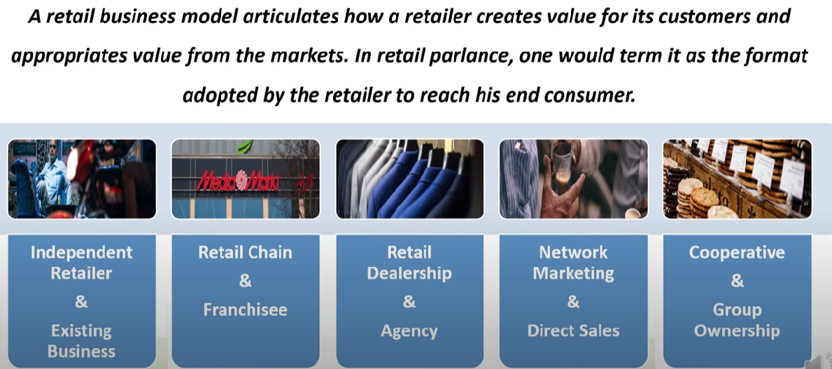

**Different Sectors In Retail Industry**

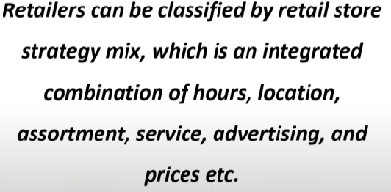

|  |  |  |  |
| --- | --- | --- | --- |
| **Drug Store** | **Auto Retailers** | **Grocery Stores** | **Multichannel Stores** |
| **Convenience Stores** | **Specialty Stores** | **Department Stores** | **Supermarkets/Hypermarkets** |

**Some Sectors in Retail Industry**

**Value Chain & Business Strategy of Retail Industry**

Value Chain describes how an Industry is structured and its methods of maximizing revenue.

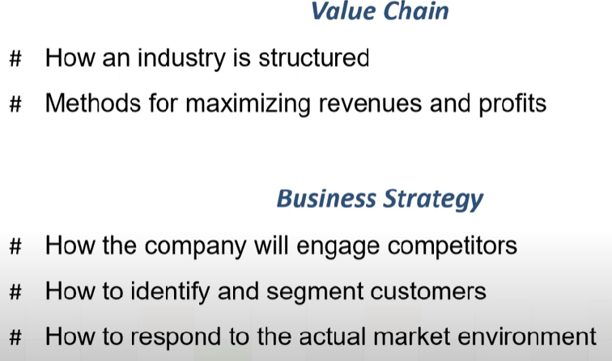

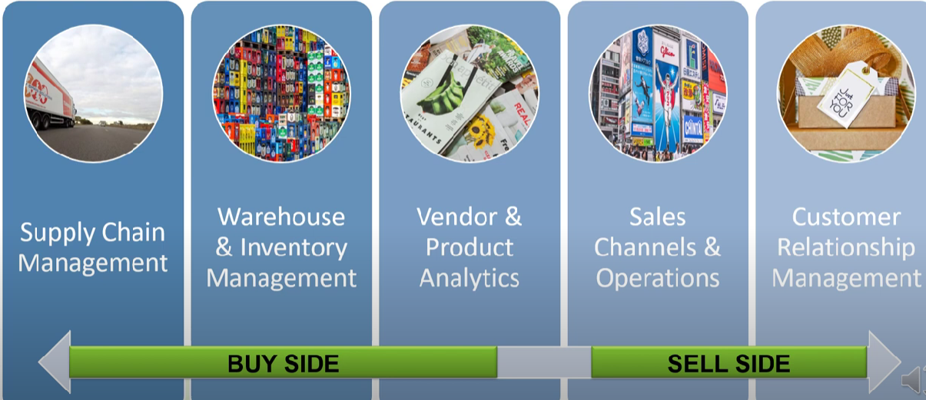

**Revenue Model of Retail Industry**

**Margin / Turnover**

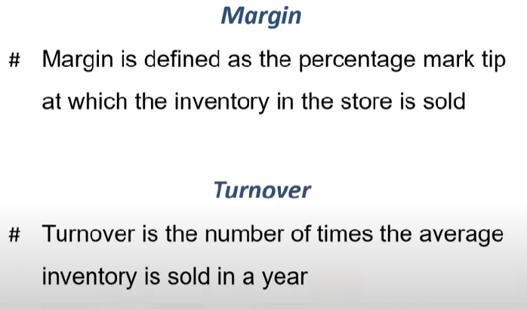

**4 types of Revenue Models in Retail**

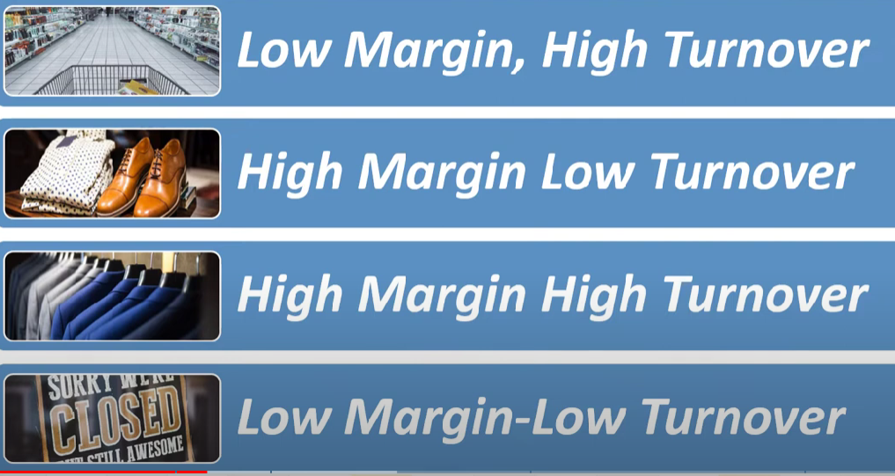

**Drivers and Dynamics of the Retail Industry**

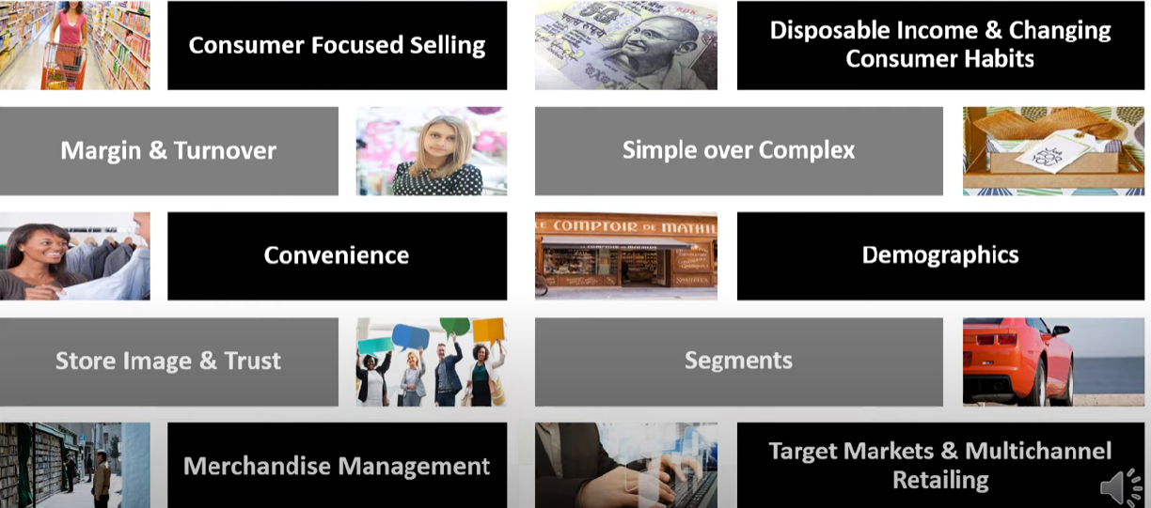

**PERFORMANCE METRICS IN RETAIL INDUSTRY**

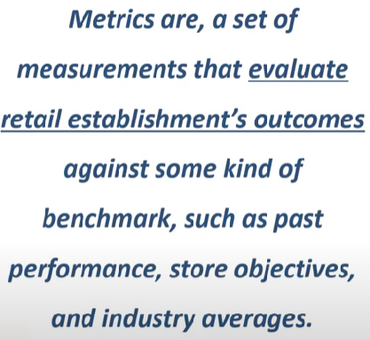

1. 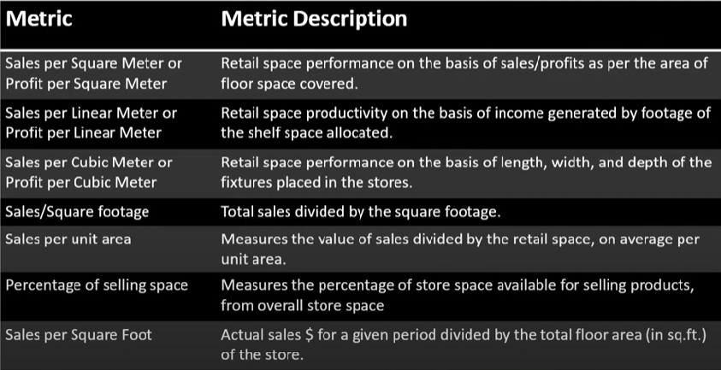**Metric Based O Retail Sales Performance**
2. **Metric Based on Financial performance**

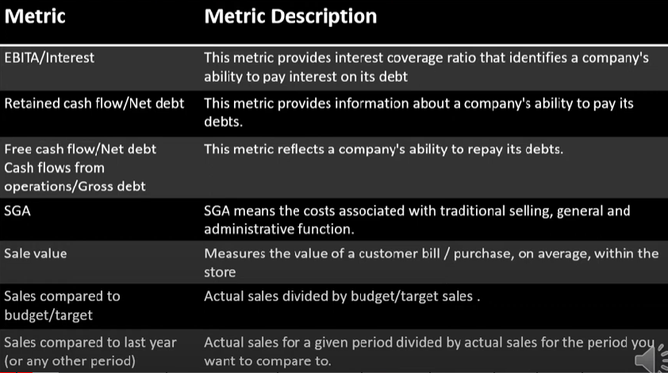

1. **Metric Based on Product Performance**

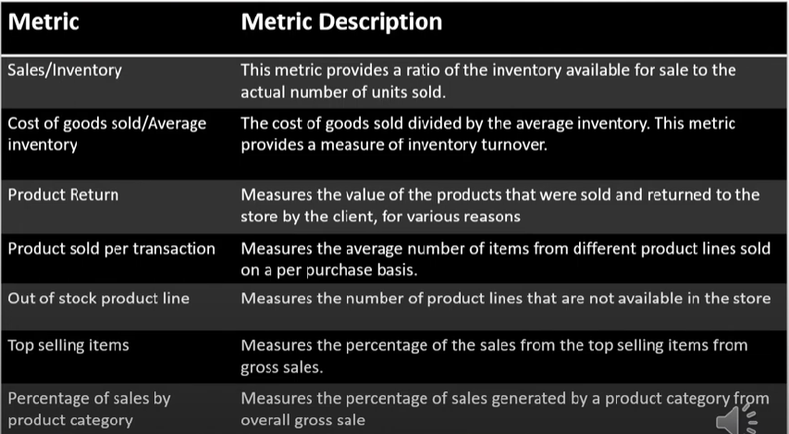

1. **Metric Based on Customer Engagement**

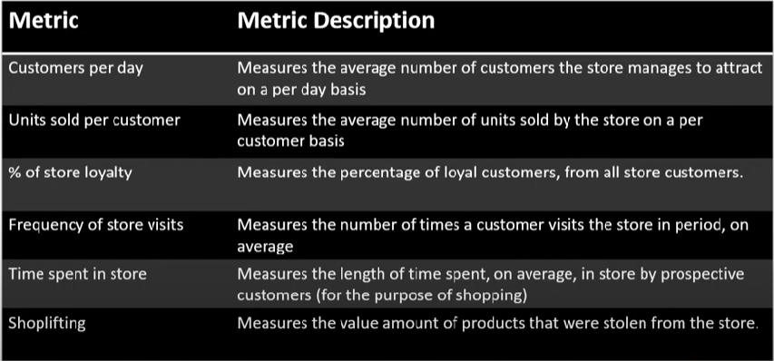

1. **Metric Based on a particular sector of population**

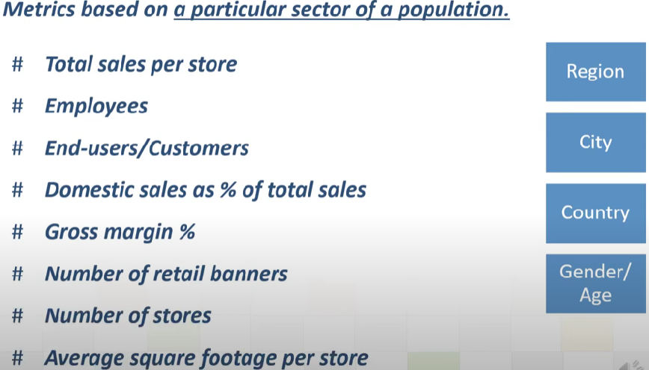

1. **Metrics Tracking Store Operations**

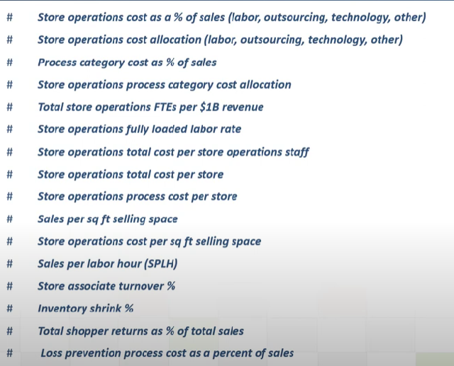

1. **Mertics Tracking Merchendise**

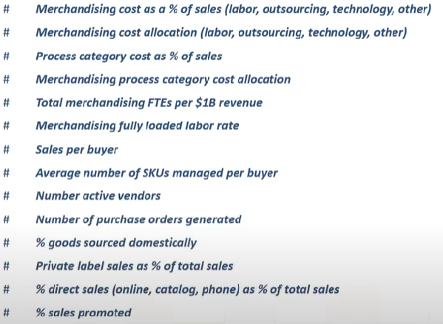

1. **Supply Chain Metrics**

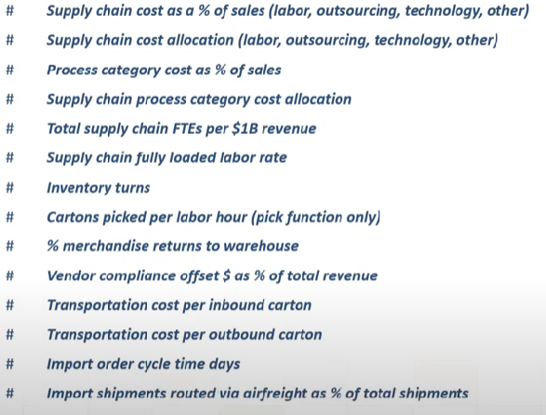

**Business Intelligence**

